**DAILY ONLINE ACTIVITIES SUMMARY**

|  |  |  |  |  |  |  |  |  |
| --- | --- | --- | --- | --- | --- | --- | --- | --- |
| **Date:** | **21-05-2020** | | | | | **Name:** | **Raksha S** | |
| **Sem & Sec** | **6th B** | | | | | **USN:** | **4AL17CS073** | |
| **Online Test Summary** | | | | | | | | |
| **Subject** | | **Operating system(OS)** | | | | | | |
| **Max. Marks** | | **30** | | **Score** | | | **30** | |
| **Certification Course Summary** | | | | | | | | |
| **Course** | **FullStack Webdevelopment & Cyber Security Specialisation** | | | | | | | |
| **Certificate Provider** | | | **Greatlearning**  **udemy** | | **Duration** | | | **45 days**  **40 days** |
| **Coding Challenges** | | | | | | | | |
| Problem Statement: 1. Write C Program to create Singly Liked List with n elements and reverse the elements.  2. Write a C program to construct a singly linked list by removing duplicate elements in the sorted linked list Description: Take a sorted list and traverse the list. Compare the current node element with next adjacent node. If it is same then delete second element, if not retain. Finally print the resulting list. Sample output: Given list {1,2,2,3,3,3,4} Resulting list{1,2,3,4} | | | | | | | | |
| **Status:** YES, Completed all Programs | | | | | | | | |
| **Uploaded the report in Github** | | | | | **YES** | | | |
| **If yes Repository name** | | | | | https://github.com/raksha05/Daily-Status/Raksha4AL17CS073/Raksha | | | |
| **Uploaded the report in slack** | | | | | **YES** | | | |

Online Test Details:

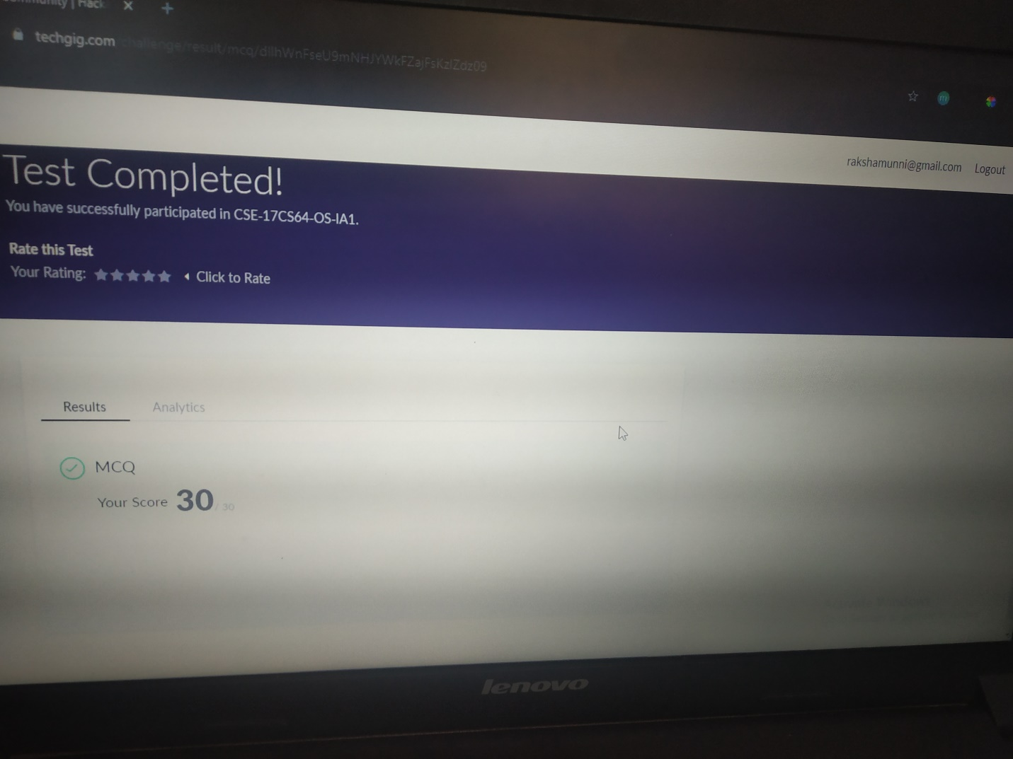

Scored 30 out of 30 in OS 1st I.A test

Certification Course Details:

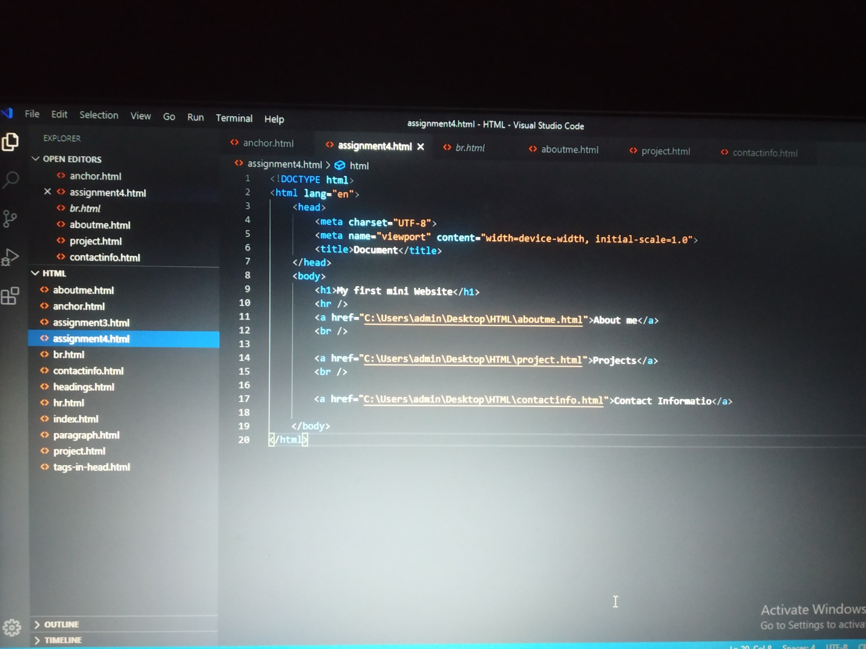

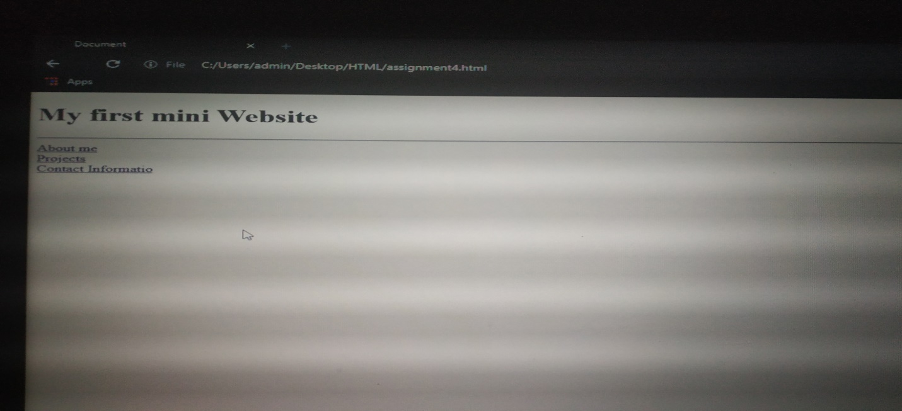

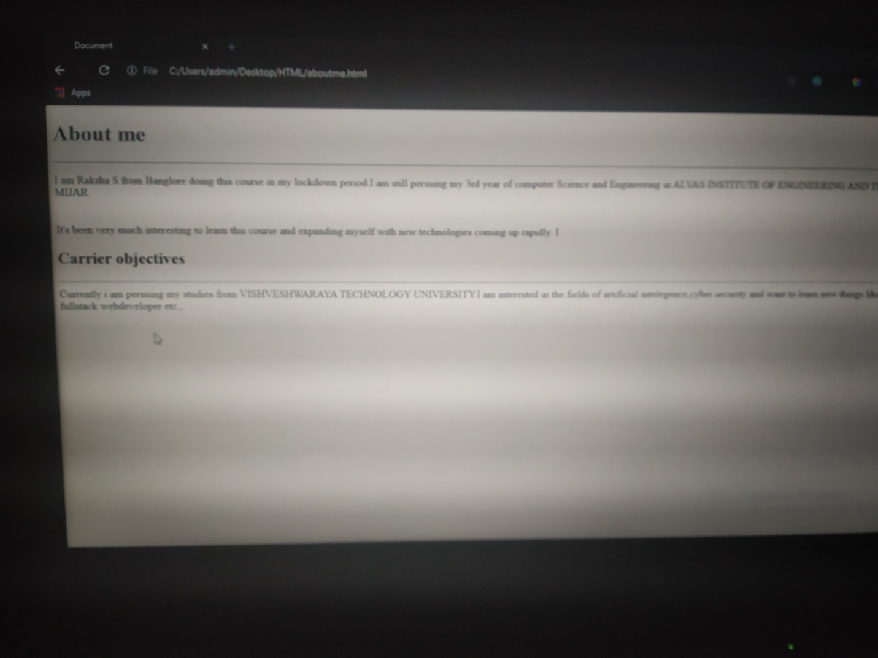

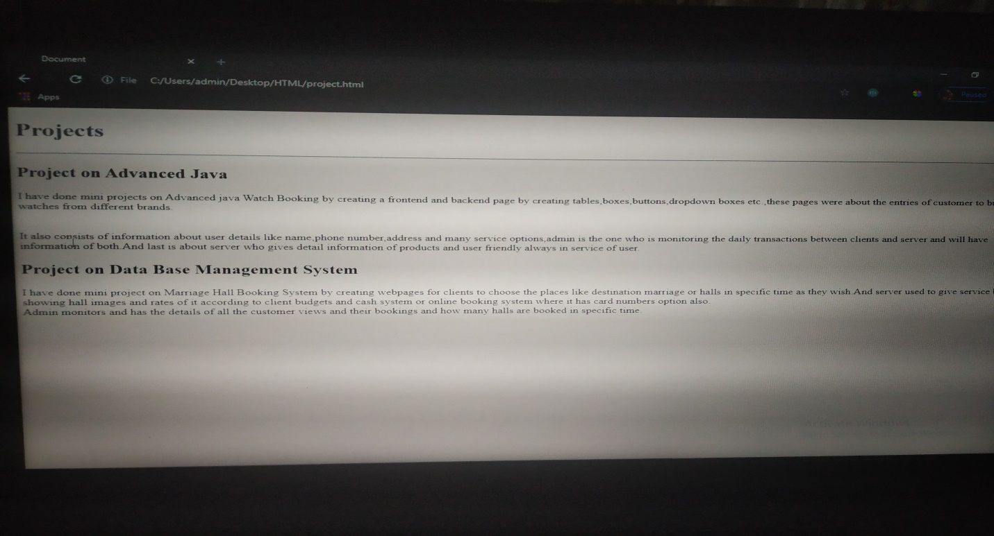

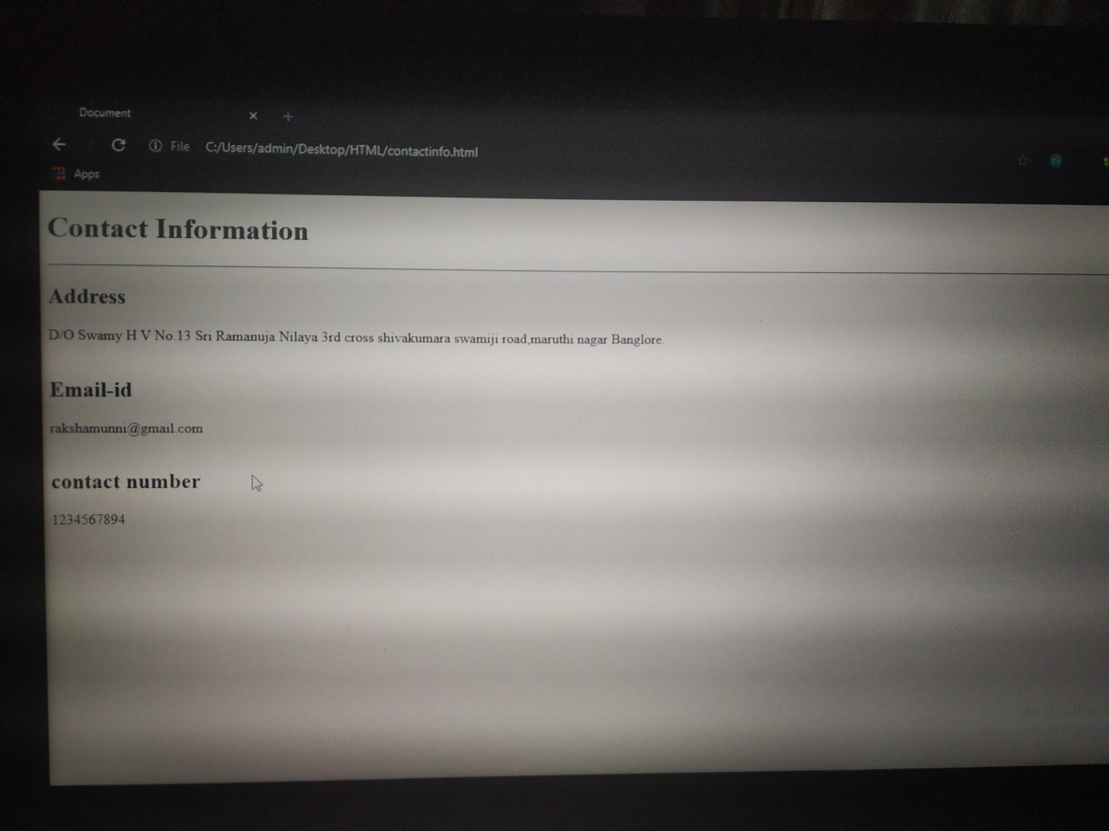

The above course is being taken up by me is based on FullStack webdevelopment. It started with the html tags, today in online course I studied about hr tag,anchor tag,br tag.And above is the assignment given to me by great learning to create a mini website of myself which contains 3 wepages as about myself,projects and contact information using anchor tag,br tag,hr tag.I learnt these tags and accordingly filled the informations of respective webpages.

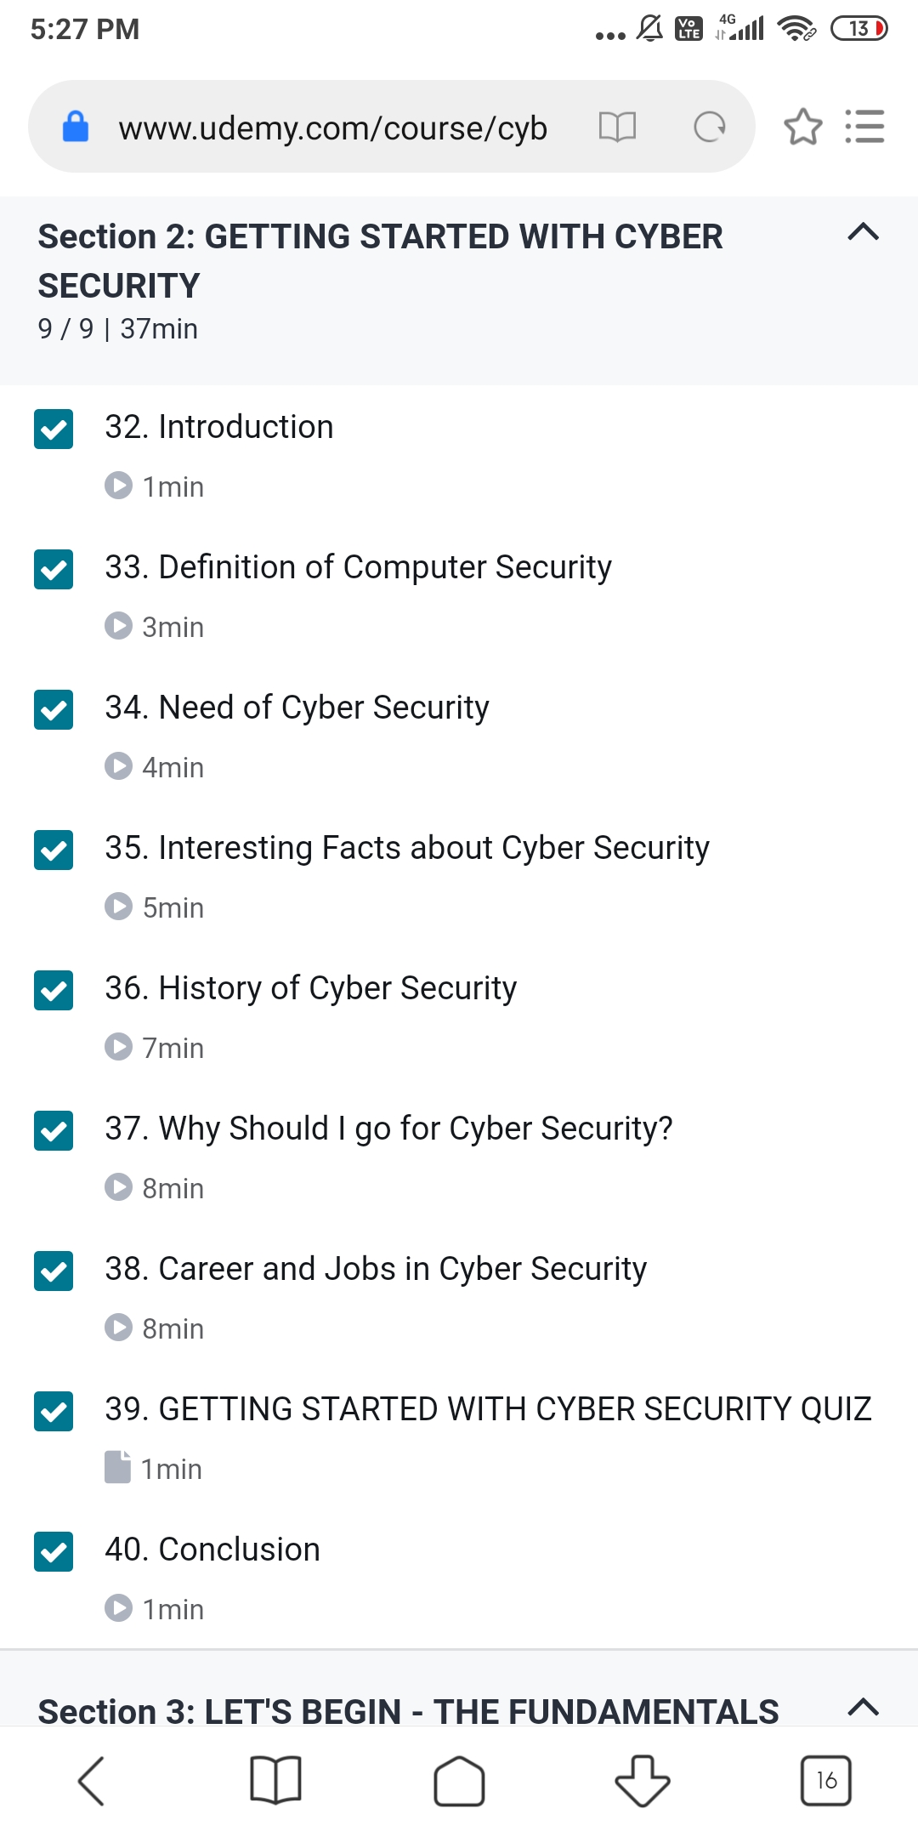

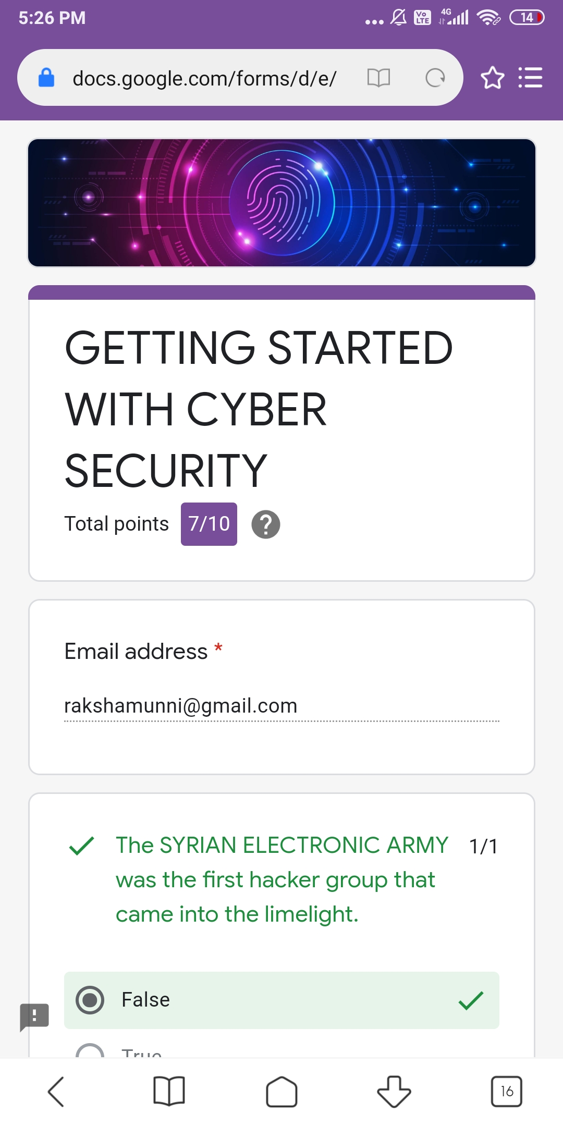

The above certification course is choosen by me based on CyberSecurity Specialisation where it started with basics of networking.Today I learnt about history of cybersecurity and its massive importance in emerging field of security.And got to know about jobsequence and career in that field.I attended one quiz assignment where I scored 7 out of 10.

Coding Challenges Details:

Program1:

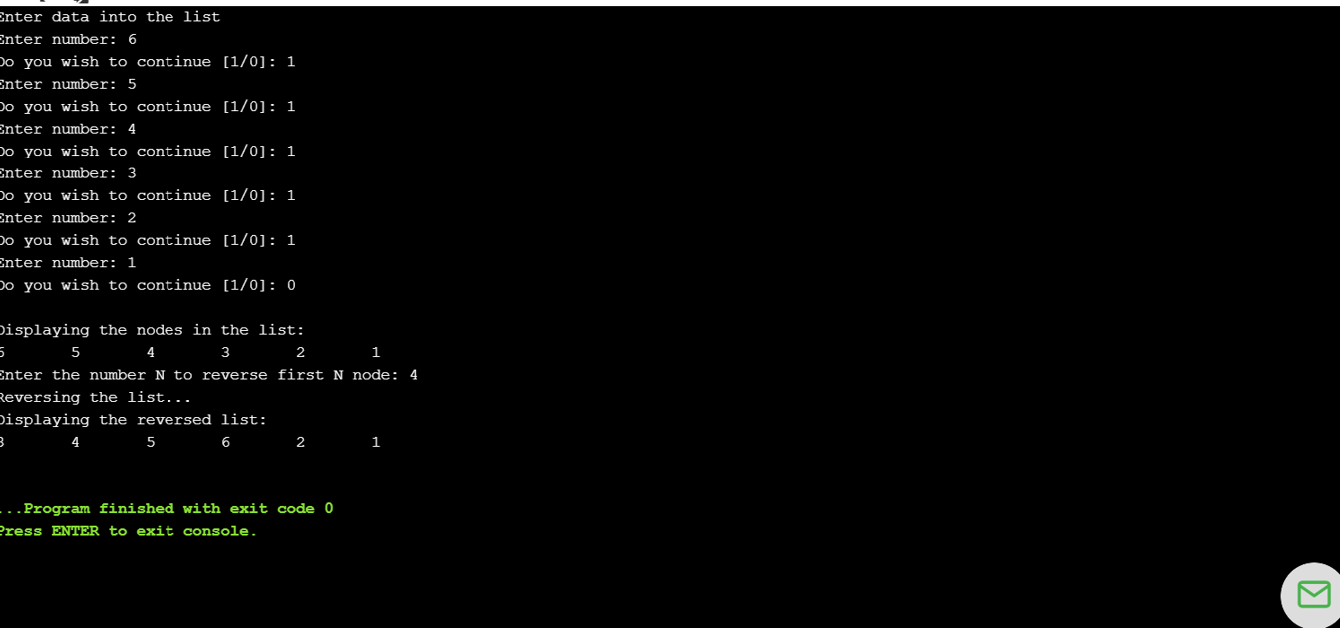

Program2:

